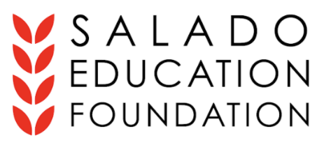
2022-2023 Taylor Willingham MINI-GRANT
APPLICATION FORM

The scope for these mini-grants includes, but is not limited to, the following categories: enhancements to the academic curriculum, educational activities, speakers, and field trips, UIL and extracurricular activities, and classroom supplies. Reimbursement for monies already paid will require receipts. Mini-grants up to $500 will be awarded monthly from September through May.

Applicants Name Date

Phone Number (include best time to call) & Email Position AND Campus

PROJECT TITLE Amount Requested (up to $500.00)

Applicant’s Signature

NOTE: SEF will gain approval for your grant project from your campus Principal before awarding your funds.
Please forward this proposal by either of the following methods:
Drop-Off Salado Middle School Office – Bunny Pierce
Email: bunny.pierce@saladoisd.org

If your application is not chosen, check the box if you would like your application to be considered for the remainder of the school year.

Application Deadline: Due by the 25th of each month.

What issue does your request/project address? Is there a cutoff date involved with this issue? If yes, please include that date.

Please describe your request/project in a manner that the Mini-Grant Committee and SEF board will understand. (Attach extra paper if needed)

Specifically, how will this request/project impact your students, benefit your classroom or empower you?

